Name __________________ period ___
Europe Geography Study Guide
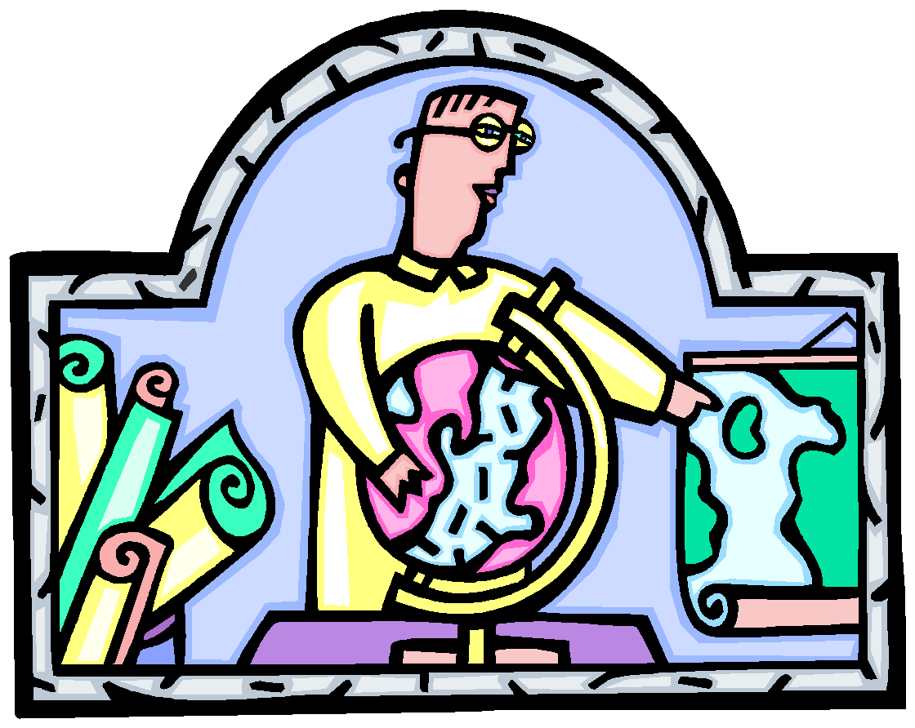
Locate on a map, the following countries, landforms and bodies of water:
http://www. Sheppardsoftware.com/geography.htm to practice countries on the political map
United Kingdom Russia Poland Italy
Germany France Spain Denmark
Portugal Austria Sweden Ukraine
Turkey Netherlands

Students should use their physical maps (created in class) to study landforms and bodies of water.
Mediterranean Sea Black Sea Rhine River Arctic Ocean
Danube River Thames River English Channel Atlantic Ocean
The Alps Pyrenees Mountains Ural Mountains Baltic Sea
North European Plain Iberian Peninsula Scandinavian Peninsula North Sea
Volga River

Refer to your class geography notes, environment venn diagram, and map skills practice.
- 3 Factors that affect the climate of a Europe
- 4 Factors that help support the economy of Europe
- Causes and effects of acid rain in Germany, air pollution in the UK, and the nuclear incident in Chernobyl
- Know these terms:
- Hemisphere
- peninsula
- Absolute location
- What are the rules for writing and using latitude and longitude?
- How do you measure using map scale?

